ADVANCE SOFTWARE ENGINEERING

ASSIGNMENT -9

NAME : PRATAP RAO KADARI

CLASS ID : 20

This is the node java to excute ionic.

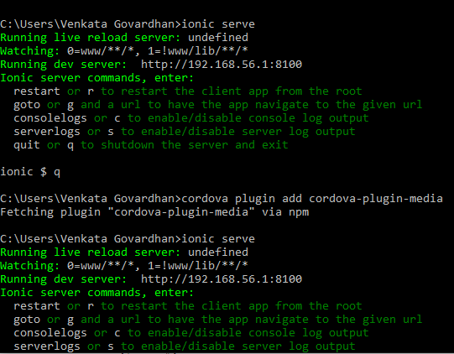

This image is captured using ionic serve command

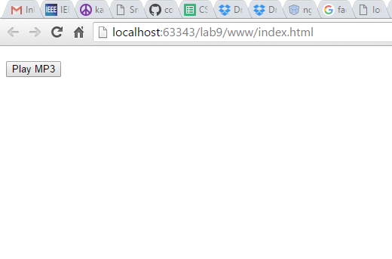

This is executed using ionic run command. Now the app is deployed on the mobile.

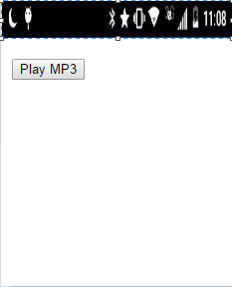

We can play sounds when we click on play MP3